PASS User Manual

- Login

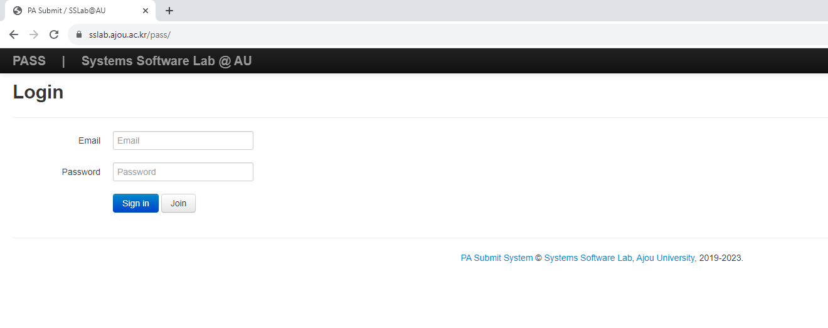
Log in through the login page (https://sslab.ajou.ac.kr/pass/).

- Assignments page

You will see a list of PAs in the Assignments page. Click Handout to download the handouts (if applicable); Click Submit to test, or submit your PAs.

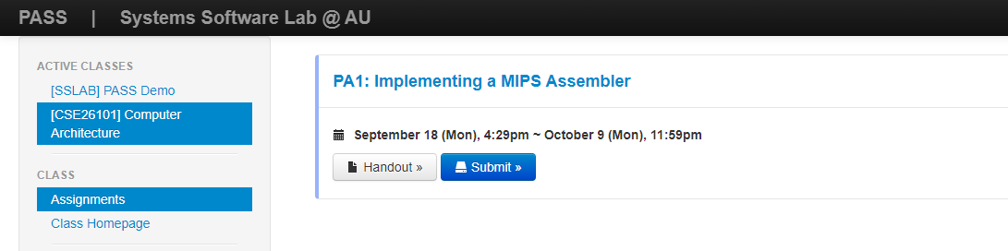
2. Click to go to the Submission page
2. Click to go to the Submission page
1. Click

3. Submitting and Testing your PA
The submission contains 3 blocks: Code, Report, and Git. We will only use Code and Report in this course.

3.1 Submitting your source code

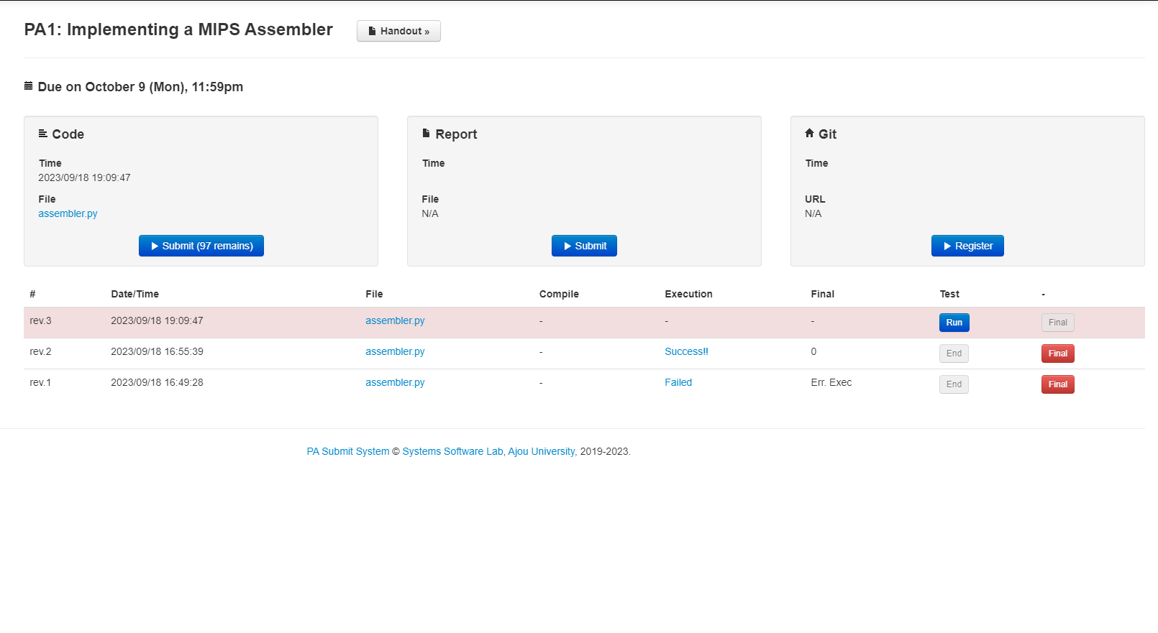
1. Upload your source code
2. Run your program

3-2. Click to see test results.
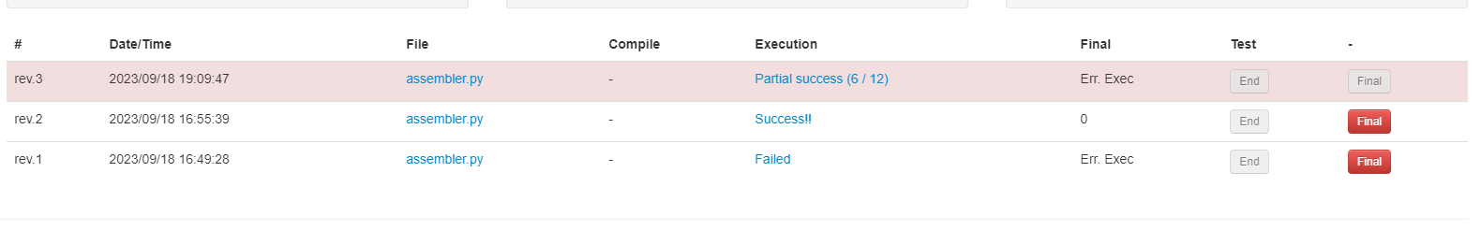
3-1. Three possible execution results

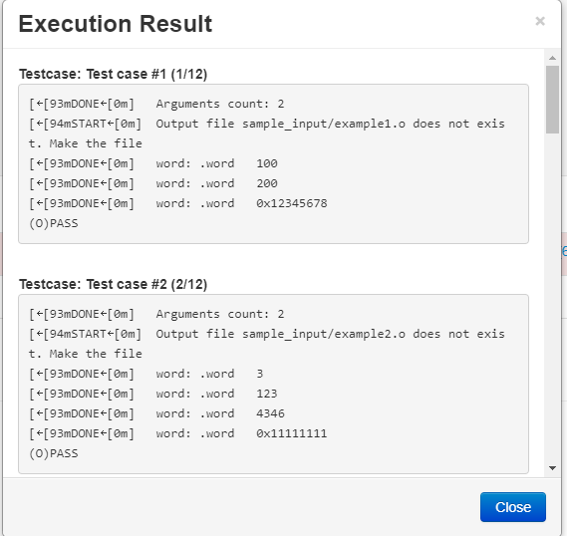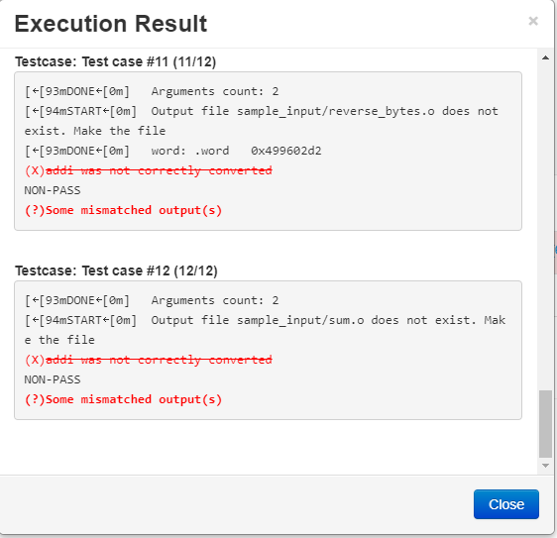
3-4. Hints are given for failed tests.
3-3. Successful tests.
4. Your current submission is marked in red.

5. You can choose which submission you want to use for grading.

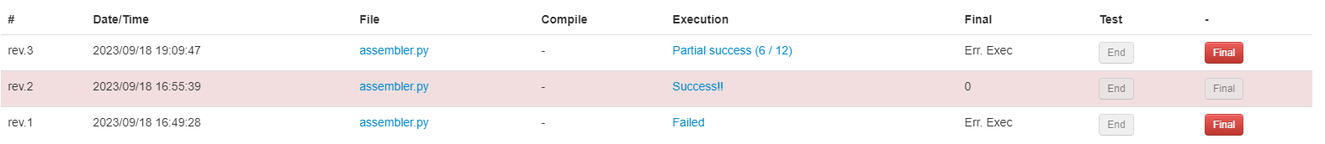
6. Hooray! Perfect score!

3.2 Submitting your report (if there is any)


Upload your report here

